BSS625 StormGuard® Professionally Pre-Engineered 25’ Straight Pole Break-Away Ball Safety Netting System and Accessories

SECTION 11 68 33 Athletic Field Equipment
(Formally Section 11480)

PART 1 GENERAL

1.01 WORK INCLUDED

A. Provide all equipment and materials, and do all work necessary to furnish
and install the athletic equipment, as indicated on the drawings and as
specified herein. Athletic equipment shall include, but not be limited to:

BSS625 StormGuard® Professionally Pre-Engineered 25’ Straight Pole Break-Away Ball Safety Netting System and Accessories

1.02 RELATED WORK

A. Examine contract documents for requirements that affect work of this
section. Other specification divisions and sections that directly relate to
the work of this section include, but are not limited to:

1. Division 03 – Concrete; Sections: Cast-in-Place Concrete
2. Division 31 – Earthwork; Sections: Excavation and Backfill and
Establishment of Sub-Grade Elevations
3. Division 32 – Exterior Improvements; Sections: Athletic and
Recreational Surfacing, Concrete, Asphalt and
Site Improvements

1.03 REFERENCES

A. Comply with applicable requirements of the following standards. Where
these standards conflict with other specified requirements, the most
restrictive requirements shall govern.

1. National Federation of State High School Associations (NFHS)
2. National Collegiate Athletic Association (NCAA)
3. International Association of Athletics Federations (IAAF)
4. American Sports Builders Association (ASBA) 5. Manufacturers Data and Recommended Installation
Requirements

1.04 SUBMITTALS

A. Manufacturers Product Data

1. Provide manufacturers product data prior to actual field
installation work, for Architects or Owners representatives
review.

B. Shop Drawings

1. Provide drawings of the manufacturers recommended
installation and foundation requirements prior to actual field
installation work, for Architects or Owners representatives
review.

1.05 QUALITY ASSURANCE

A. Manufacturers warranties shall pass to the Owner and certification made
that the product materials meet all applicable grade trademarks or conform to industry standards and inspection requirements. The Manufacturer
shall have a current American Sports Builders Association (ASBA)
Supplier Certificate of Distinction designation.

1.06 PRODUCT DELIVERY AND STORAGE

A. Materials delivered to the site shall be examined for damage or defects in shipping. Any defects shall be noted and reported to the Owners representative. Replacements, if necessary, shall be immediately re- ordered, so as to minimize any conflict with the construction schedule. Sound materials shall be stored above ground under protective cover or indoors so as to provide proper protection.

PART 2 PRODUCTS

2.01 BSS625 StormGuard® Professionally Pre-Engineered 25’ Straight Pole Break-Away Ball Safety Netting System and Accessories

A. BASE: BSS625 StormGuard® Professionally Pre-Engineered 25’
Straight Pole Break-Away Ball Safety Netting System and
Accessories as Manufactured and/or Supplied by:

Sportsfield Specialties, Inc.
P.O. Box 231
41155 State Highway 10
Delhi, NY 13753
p. 888-975-3343
f. 607-746-8481
www.sportsfieldspecialties.com

B. COMPONENTS:

- BSS625 StormGuard® Professionally Pre-Engineered Break-Away Ball Safety Netting System Straight Poles:
a. 6” Schedule 40 Aluminum Pipe (6.625” O.D.), 30’L
b. Standard Powder Coated Black Finish, Various Standard
and Custom Powder Coat Finish Color Options Available

2. StormGuard® Professionally Pre-Engineered Break-Away Ball Safety
Netting System (United States Patents #9,017,190, Issued April 28,
2015 and #9,586,123, Issued March 7, 2017):
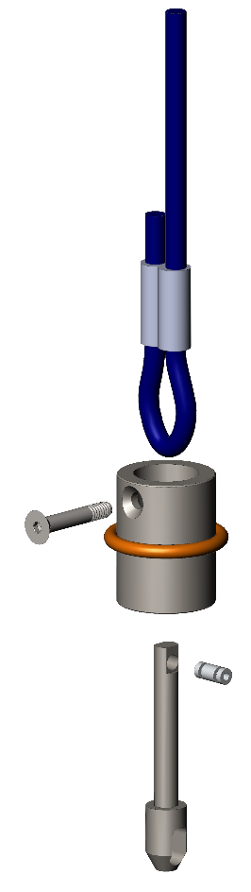
Rope Tether
a. StormGuard® is the first and only ball safety netting system in
the industry that is both designed and professionally pre-
engineered to allow the net to fall to the ground before failures
of the poles and/or hardware occur under extreme wind speed
and/or adverse weather conditions such as ice and snow. This
patented feature utilizes a shear pin device attached to the net at
the top of each pole.
Weighted Lowering Device & Removable Attachment Bolt

As shown in the diagram, the snap clip that holds the net up is
attached to the oblong shaped hole located at the bottom of
the smaller drop shaft that is connected to the cylindrical steel
weight utilizing a 150 lb. break strength aluminum shear pin.
The cylindrical steel weight is semi-permanently attached to the
rope tether that hoists the net up and down with a removable
bolt and includes a rubber absorption bumper to prevent damage
to the pole’s powder coated black finish.
Rubber Absorption
Pole Bumper
Replaceable Break-Away Shear Pin & Drop Shaft
The poles are installed at a maximum of twenty-five foot (25’)
on center or less. When the wind speed exceeds approximately
sixty-five to seventy miles per hour (65 - 70 mph), the 150 lb.
break strength aluminum shear pin will react to the
environmental conditions by allowing the smaller drop shaft to
release from the cylindrical steel weight causing the net to fall to
the ground. The end user then simply unwinds the rope tether
from the cleat, lowers the cylindrical steel weight to the ground,
replaces the already provided aluminum shear pin and raises the
net back up.
StormGuard® Break-Away
Ball Safety Netting System
(United States Patents #9,017,190, Issued April 28, 2015 and #9,586,123, Issued March 7, 2017)

3. Ground Sleeves with Welded Base Plates:
a. 48”L Ground Sleeves
b. Steel Tube with Alignment Bolt

4. Net with Perimeter Rope Binding:
a. Overall Dimensions Specified by Customer
b. 1-3/4" Square Mesh
c. #36 Black Nylon
d. Sewn 1/4” Diameter Braided Rope Binding on Perimeter Edges
e. Standard Color is Black

5. Included Accessories:
a. Stainless Steel and/or Galvanized Steel Assembly Hardware
b. Fixed Welded Upper Tab and Adjustable Lower Bracket with
Tensioned Vertical Slide Cable System
c. Secure Snap Clips for Net Attachment
d. 3/16” Diameter Galvanized Wire Rope Black Vinyl Coated to
1/4” Diameter
e. Aluminum Ground Sleeve Caps
f. Model Specific Hardware Kit and Installation Instructions

6. Optional Accessories:
a. Base Plate Mount Ball Safety Netting Systems
b. Custom Ball Safety Netting System Sizes and Designs Available
Upon Request
c. Custom Net Mesh Sizes and Colors Available Upon Request
d. Stamped and Sealed Drawings and Calculations by a Licensed
Professional Engineer of Record in the State of Project Location

PART 3 EXECUTION

3.01 INSTALLATION OF EQUIPMENT

A. All BSS625 StormGuard® Professionally Pre-Engineered 25’ Straight Pole Break-Away Ball Safety Netting System and Accessories shall be installed as recommended per manufacturer's written instructions and as indicated on the drawings. Concrete anchoring foundations to be determined by others based on local soil conditions and building codes. Installer should have a minimum of five (5) ball safety netting system installations or similar experience in the previous three (3) years.

END OF SECTION

